**A MINI PROJECT REPORT ON**

**Automatic plant watering system**

**Submitted in partial fulfilments for the award of the**

**Digital Thinking Lab (Mini Project)**

**Submitted by**

**B. Gayatri(24A81A0606)**

**K.S.V. Arun Kumar(24A81A0629)**

**P. Pushpa Madhuri(24A81A0641)**

**S. Akhila(24A81A0649)**

**Y. Mohini Anuradha(24A81A0663)**

**Under the Guidance of**

**Dr.P. Rama Mohana Rao**

**Assistant Professor**



**Department of Computer Science and Technology**

**SRI VASAVI ENGINEERING COLLEGE(Autonomous)**

**(Affiliated to JNTUK, Kakinada)**

**Pedatadepalli, Tadepalligudem-534101, A.P(2024-25)**

**SRIVASAVIENGINEERING COLLEGE(Autonomous)**

**Department of** **Computer Science and Technology**

Pedatadepalli, Tadepalligudem



Certificate

This is to certify that the project report entitled**“Automatic**

**Plant Watering System”** Submitted by, Y**. Mohini Anuradha(24A81A0663) Batch-6** for the award of the Design Thinking and Innovation in the Department of Computer Science and Technology during 3rdsem in the academic year 2024-25.

**Name of the project Guide Head of Department**

**Dr.P. Ram Mohana Rao D.JayaKumari**

**Assistant professor Professor&HOD**

**DECLARATION**

We hereby declare that the project work entitled **“Automatic Plant Watering System** “submitted to the Sri Vasavi Engineering college is a record of an original work done by **B. Gayatri (24A81A0606), K.S.V. Arun**

**Kumar(24A81A0629), P. Pushpa Madhuri(24A81A0641), S. Akhila(24A81A0649), Y. Mohini** Anuradha(24A81A0663) under the esteemed guidance of **Dr. P. Ram Mohana Rao, Assistant Professor,** Department of Computer Science and Engineering, Sri Vasavi engineering College. This project work is submitted in partial fulfillment of the requirements for the award of the degree Computer Science and Technology. This entire project is done to the best of our knowledge and has not been submitted for the award of any other degree in any other university.

**B. Gayatri(24A81A0606)**

**K.S.V. Arun Kumar(24A81A0629)**

**P. Pushpa Madhuri(24A81A0641)**

**S. Akhila(24A81A0649)**

**Y. Mohini Anuradha(24A81A0663)**

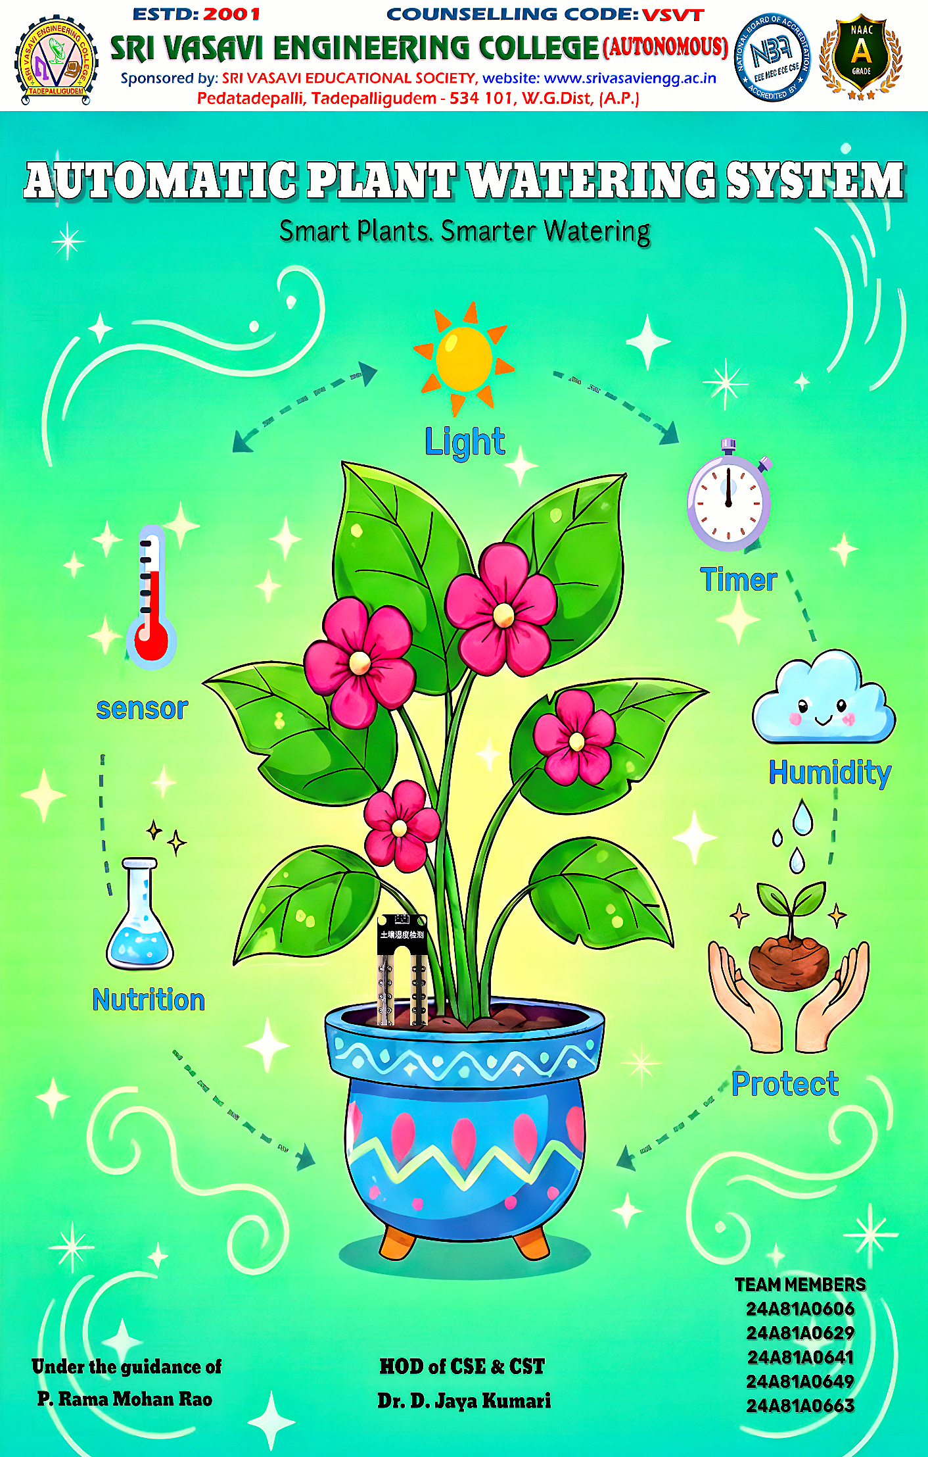

**AUTOMATIC PLANT WATERING SYSTEM**

**ABSTRACT:**

The Automatic Plant Watering System Using Sensors is designed to automate the irrigation process for plants, ensuring optimal water supply based on soil moisture levels and environmental conditions. The system employs various sensors—primarily a soil moisture sensor, which continuously monitors the water content in the soil. When the moisture level drops below a predefined threshold, the system automatically activates a water pump to irrigate the plant until the soil reaches the required moisture level, after which the pump is turned off.

The system’s control logic is managed by a microcontroller (such as Arduino, ESP32, or Raspberry Pi), which processes sensor data and operates the pump through relay circuits. Additional sensors, like temperature, humidity, and light intensity sensors, can be integrated to enhance precision and adapt watering schedules to environmental factors. A power supply (from battery or solar source) ensures continuous operation, while indicators or display modules (like LCD or LEDs) provide real-time feedback to the user.

This automated approach minimizes human intervention, conserves water by preventing over-irrigation, and promotes healthy plant growth by maintaining consistent moisture levels. The system is especially beneficial in agricultural fields, greenhouses, and home gardens where regular manual watering is impractical. The theoretical framework behind this system integrates IoT (Internet of Things) and embedded system principles, allowing for potential remote monitoring and control through mobile or web applications.

**Bottom of Form**

|  |  |  |  |  |  |  |
| --- | --- | --- | --- | --- | --- | --- |
|  |  |  |  |  |  |  |
|  |  |  |  |  |  |  |
|  |  |  |  |  |  |  |

**INDEX**

|  |  |  |
| --- | --- | --- |
| S.NO | NAME OF THE TOPIC | PAGE NO |
| 1. | Detailed Explanation about **Automatic Plant Watering System** |  |
| 2. | Design Thinking and Innovation Process |  |
| 3. | **Phase 1: EMPATHIZE**  3.1. Survey and Questionaries  3.2. Observations |  |
| 4. | **Phase 2: Define**  4.1. Problem Statement  4.2. Solution |  |
| 5. | **Phase 3: Ideate**  5.1. Different Possible Solutions  5.2. Final Solution |  |
| 6. | **Phase 4: Prototype**  6.1. Solution Chart |  |
| 7. | **Phase 5: Testing and Conclusion**  7.1. Final Testing |  |

**INTRODUCTION**

**Detailed Explanation of Automatic Plant Watering System**

An automatic plant watering system using sensors is an innovative, intelligent irrigation solution designed to ensure that plants receive the right amount of water at the right time without human intervention. The main concept behind this system is the automatic detection of soil moisture levels using electronic sensors, followed by the automatic control of a water pump or valve based on that data. It operates on the principle that the electrical resistance or capacitance of soil varies with its water content—wet soil conducts electricity better, while dry soil has higher resistance. The system consists of several essential components including a soil moisture sensor, microcontroller, relay module, water pump, power supply, and water distribution network. The soil moisture sensor continuously monitors the moisture content of the soil and sends an analog signal to the microcontroller. This signal is converted into a digital value using an Analog-to-Digital Converter (ADC) within the microcontroller. The microcontroller, which serves as the brain of the system, compares this value with a pre-set threshold. If the moisture level is found to be below the threshold, it triggers the relay module, which acts as an electronic switch to turn on the water pump. The pump then draws water from a reservoir or water tank and supplies it to the plants through pipes or drip irrigation lines. As water seeps into the soil and the moisture level increases, the sensor detects the change and sends updated readings to the microcontroller. When the soil moisture reaches the desired level, the microcontroller deactivates the relay, turning off the pump and stopping the water flow.

This process ensures that plants are neither under-watered nor over-watered, maintaining the ideal moisture conditions for growth. The system operates continuously in a closed-loop feedback cycle, automatically responding to changing soil conditions. The power supply provides the required energy to all components, which can be sourced from a DC adapter, battery, or even solar panels for sustainable operation. Additional features such as LCD displays or indicator LEDs can be used to show real-time moisture levels, pump status, or system activity. For more advanced applications, the system can be enhanced with IoT (Internet of Things) capabilities using Wi-Fi or GSM modules, enabling remote monitoring and control through mobile apps or web dashboards. Furthermore, integrating temperature, humidity, or rain sensors allows the system to make smarter watering decisions based on environmental conditions.

Overall, the automatic plant watering system is a reliable, efficient, and environmentally friendly technology that conserves water, saves time, and promotes healthy plant growth. It is highly beneficial for home gardens, greenhouses, agricultural fields, and landscaping applications. By automating the irrigation process and minimizing human effort, it not only increases productivity but also contributes to sustainable water management. The system represents a significant step toward modern smart farming and precision agriculture, where automation, sensors, and intelligent control systems work together to optimize resources and enhance crop yield.

**DESIGN THINKING PROCESS**

**Design Thinking Process:**

The Design Thinking Process is human- centred, iterative, and creative.

Problem-solving approach. It empowers individuals to empathize with users, challenge assumptions, and prototype innovative solutions.

There are five key steps in design thinking process:

1. Empathize.

2. Define.

3. Ideate.

4. Prototype.

5. Test.

The principles of design thinking process are Human-Centred, Empathy, Creativity, Iteration and collaboration.



**PHASE: 1**

**EMPATHISE**

**Empathize:**

During this stage, design teams set aside their own biases and their work to gain a deeper understanding of real values and their needs-often through direct observation and engagement. He empathizes phase is all about deeply understanding the users you're designing for. It’s the first step in the Design Thinking process. Here, you dive into the lives of the users, their emotions, challenges, needs, and aspirations.

**Methods used to conduct this user research are: -**

1. **User Interview:** Talk to users directly to gain insight into their challenges and understanding their points of view.



**2. Survey and Questionnaires:** Help identify who your users are, what they currently think about your product, what problems they face, and what their needs are.



**3. Observation: Views** how users interact with the product and their environment. Observe their behaviour to gain insight into their thought and feelings.



**4. Empathy map:** A visualization how that summarizer’s a user’s thoughts, actions and their feelings.



**Observations**

**1)B. Gayatri(24A81A0606): Project head &understanding the plants**

Gayatri understands the relationship between soil, water, and plant health; how sensors detect environmental conditions; how technology can automate natural processes; and why efficient water management is essential. These observations not only enhance their scientific and technological knowledge but also nurture environmental awareness and curiosity about sustainable living.

**2)K.S.V. Arun Kumar(24A81A0629): Sensor Selection and Testing**

Arun performs **sensor selection and testing** in an automatic plant watering system project, they observe various technical and practical aspects that help them understand how to choose, calibrate, and use sensors effectively. These observations give insight into how sensors respond to environmental conditions, their accuracy, and their importance in automation systems.

**3) P. Pushpa Madhuri(24A81A0641): System design and logic**

Madhuri study or build the system design and logic of an automatic plant watering system, they make several key observations about how the entire setup functions as an integrated, intelligent system. Through this, they understand how different electronic components, sensors, and control logic work together to automate the watering process.

4)**S. Akhila(24A81A0649): Time planner and set the budget**

Akhila work on the **time planning and budgeting** stage of an **automatic plant watering system** project, they make several important observations about **project management, cost control, and resource allocation**. This stage helps them understand that successful engineering or science projects are not only about building circuits but also about **planning, scheduling, and financial management**.

**5) Y. Mohini Anuradha(24A81A0663): Documentation and evaluation**

Anuradha work on the documentation stage of an automatic plant watering system project, they observe the importance of clearly recording every step of their work—from planning and design to testing and results. Through this process, they learn that proper documentation is essential for understanding, presenting, and improving a technical project.



**PHASE-2**

**DEFINE**



The second step is to define the problem. In this phase, designers analyse the data gathered during the previous stage to identify and define the issue with a clear and concise problem statement.

**PROBLEM STATEMENT**

**PROBLEM:**

Many people enjoy growing plants at home, but they often face challenges in maintaining proper watering, especially when away from home. Forgetting to water can lead to dry soil, affecting plant health, while overwatering can cause root rot.

**SOLUTION:**

This project presents an automatic smart plant watering system using a soil moisture sensor, Arduino UNO, and a relay-controlled motor pump. The system continuously monitors soil moisture levels. When the soil is dry, the sensor signals the Arduino to activate the pump and water the plant. Once the soil is sufficiently wet, the pump stops automatically. Additionally, a time-based watering feature ensures that watering occurs at regular intervals, preventing plant stress due to rapid soil drying in hot weather. This solution provides a reliable and efficient method to maintain plant health, reduces human intervention, saves water, and ensures that plants receive adequate care even in the absence of the owner.

**Problem and Solution of Automatic plant watering System**

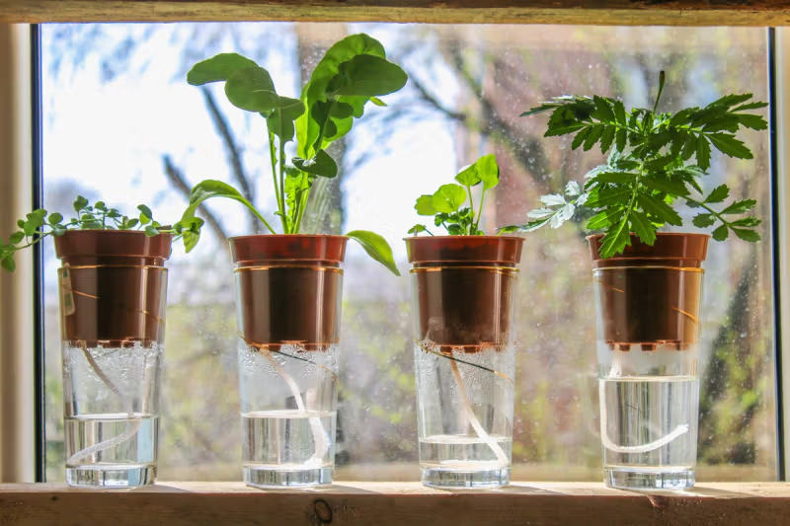

**PHASE- 3:**

**IDEATE**

**Ideate:**

The ideation stage is where designers start to explore solutions. Ideas in this stage will ultimately become prototypes that can be tested with your target audience.

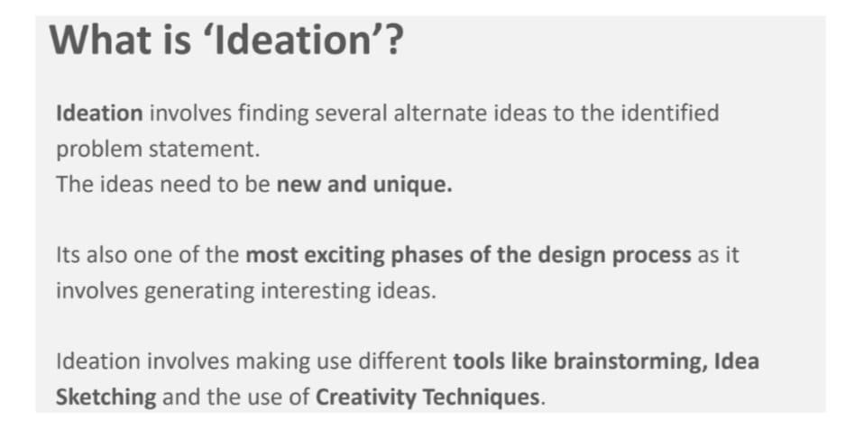

**Different possible solutions on Automatic plant watering system**

**Solution 1: Sensor-Based Automatic System**

* Uses a soil moisture sensor to detect the moisture content of soil.
* When the soil becomes dry, the sensor sends a signal to the microcontroller.
* The controller turns ON the water pump until the soil reaches the required moisture level.
* Pump then automatically stops.

**Components:**

* Soil Moisture Sensor
* Arduino / Microcontroller
* Relay Module
* DC Water Pump
* Power Supply

**Advantages:**

* Provides accurate watering based on real soil condition
* Saves water and energy
* Fully automatic

**Disadvantages:**

* Sensor may need calibration or replacement over time
* Requires some coding and circuit setup

**Solution 2: Timer-Based Watering System (No Sensors)**

* A digital or analog timer controls when the pump turns ON and OFF.
* Example: Pump runs for 5 minutes every 6 hours.
* Watering happens automatically at fixed intervals.

**Components:**

* Timer circuit (e.g., 555 Timer, RTC module, or digital timer)
* Relay and Pump
* Power Supply

**Advantages:**

* Simple, low cost
* Easy to implement

**Disadvantages**:

* Cannot adjust to weather or soil moisture
* May overwater or underwater plants

**Final Solution**:

The final solution of the automatic plant watering system is a fully functional setup that **automatically irrigates plants based on real-time soil moisture conditions**. The system uses a **soil moisture sensor** to continuously monitor the water content in the soil and a **microcontroller** (such as Arduino or ESP32) to process the sensor data and control a **water pump** through a **relay module**. When the soil becomes dry and the moisture level drops below a preset threshold, the sensor sends a low analog signal to the microcontroller. The controller then activates the relay, turning the water pump **ON** to supply water to the plant. As the soil absorbs the water, the sensor detects the increasing moisture level, and once it reaches the threshold, the microcontroller turns the pump **OFF** automatically. This process ensures that the plant receives the right amount of water at the right time, without any human intervention.

The system is powered by a 5V or 12V DC supply and can be enhanced with an LCD display to show real-time soil moisture readings and pump status. It can also be upgraded with IoT (Internet of Things) modules for remote monitoring and control. The final setup operates efficiently with minimal energy consumption and reduces water wastage by delivering water only when needed.

In conclusion, the final solution demonstrates an effective, reliable, and sustainable way to automate plant watering. It integrates **sensor technology, control logic, and feedback mechanisms** to maintain optimal soil moisture for healthy plant growth. This project not only helps in conserving water but also introduces students to the practical application of **automation, electronics, and environmental sustainability** in modern agriculture and smart home systems.

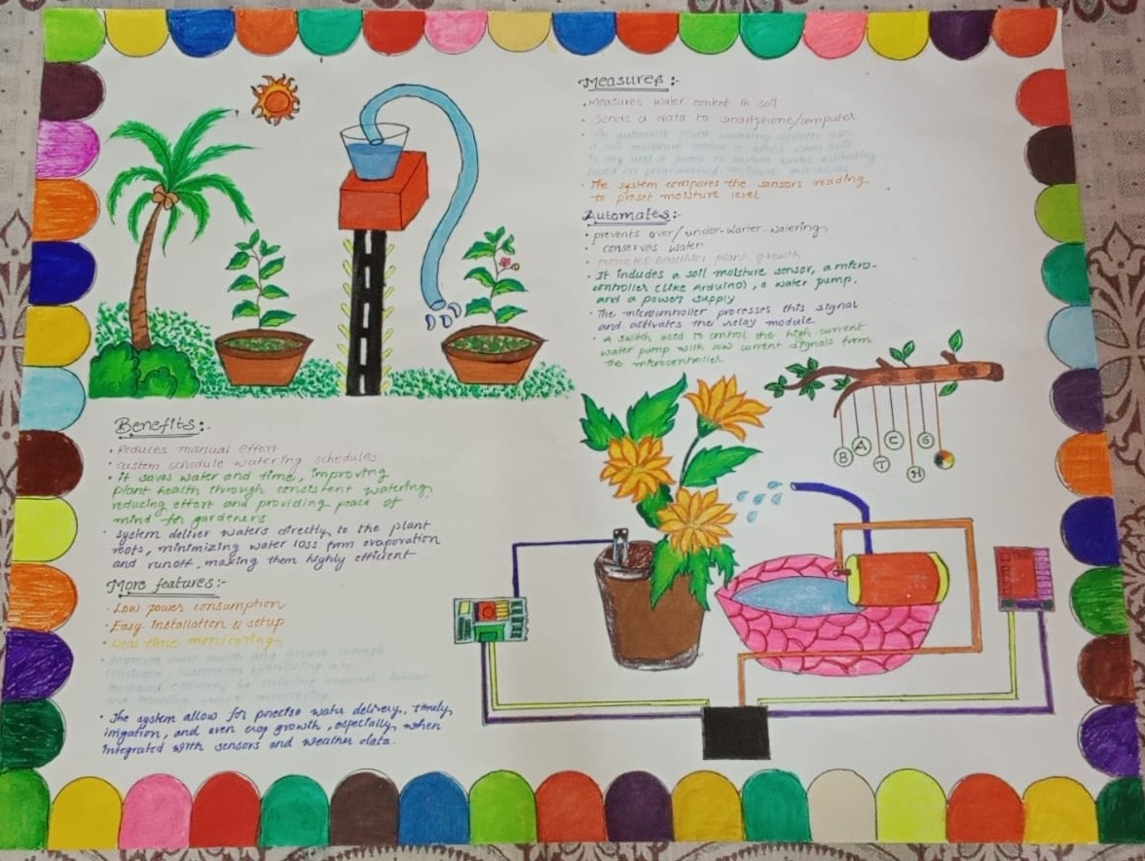

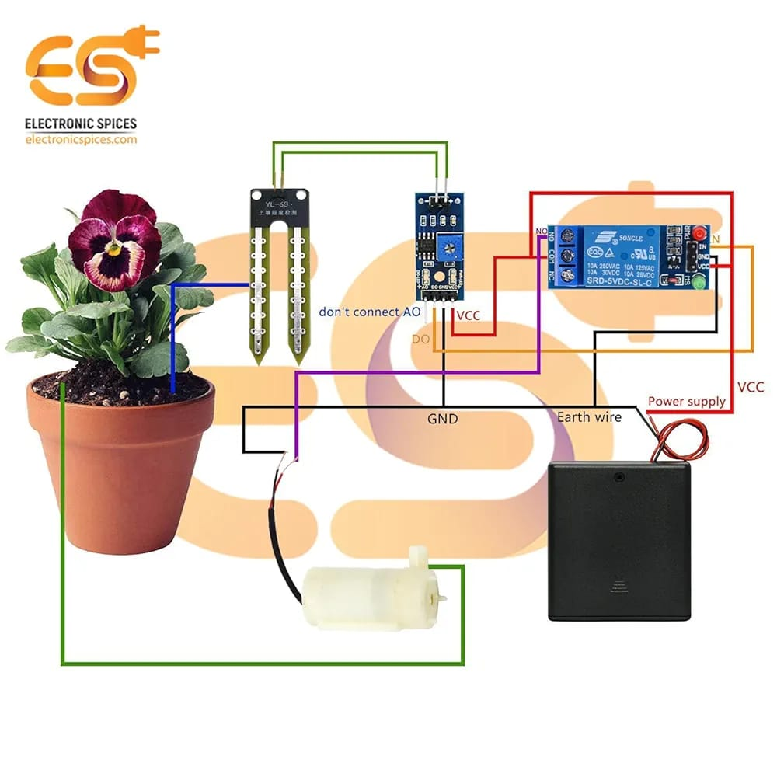

Automatic plant watering System use in different locations:

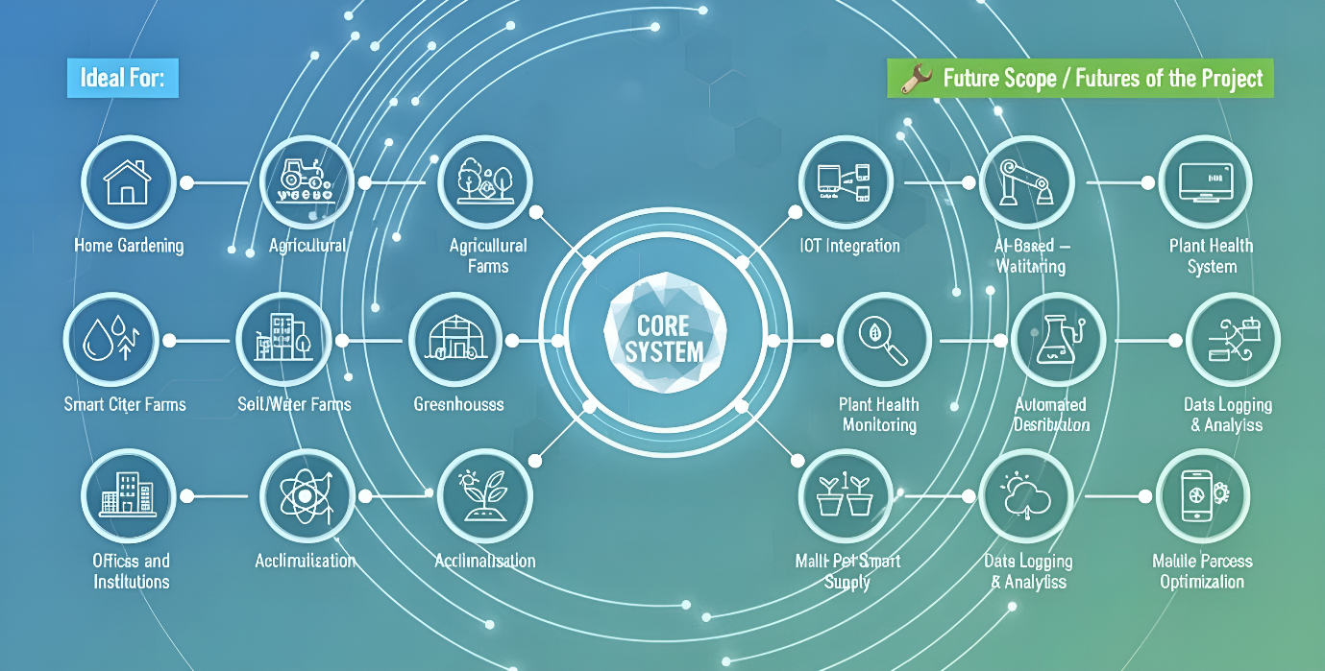

**PHASE- 4:**

**PROTOTYPE**

**Prototype:**

* Prototyping is the process of transferring ideas and experiments from your head to the physical world.
* A Prototype can be a wall of post it notes, a role-playing exercise, a space, an object, or even a storyboard.
* The Resolution of your prototype should be proportional to your project’s progress.
* Keeping your prototypes rough and brief during early explorations lets you learn quickly and study a variety of options.
* Prototypes are most successful when they can be experienced and interacted with by people,
* i.e., The design team, the user, and others.
* What you learn from those interactions can help you develop greater empathy and develop effective solutions.



**Types of Prototypes in design Thinking**

* Different types of prototypes techniques can help you to visualize and refine your designs depending on the stage of development.
* They are
* 1. Sketches and Diagrams.
* 2. Paper Interface.
* 3. Storyboards.
* 4. Role-Playing.
* 5. Physical models.

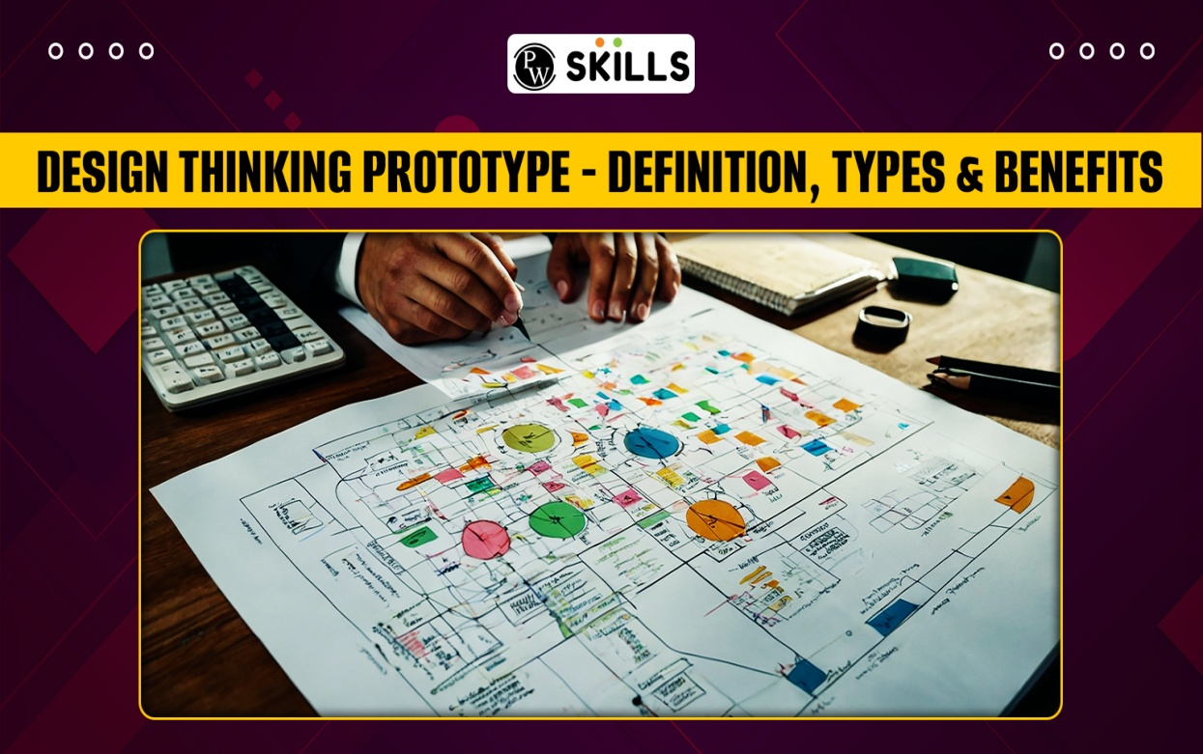

**PROTOTYPE**

**COMPONENTS REQUIRED:**

1. Soil moisture sensor with LM393
2. 5v relay module
3. Arduino uno board
4. 9v Submersible water motor pumps
5. Connecting wires
6. Plants

**1) Soil moisture sensor with LM393**

The **Soil Moisture Sensor with LM393** is a commonly used sensor module designed to detect the moisture level in the soil, which is crucial for automatic plant watering systems. It consists of two main parts: the **soil moisture sensing probe** and the **LM393 comparator-based signal processing board**.

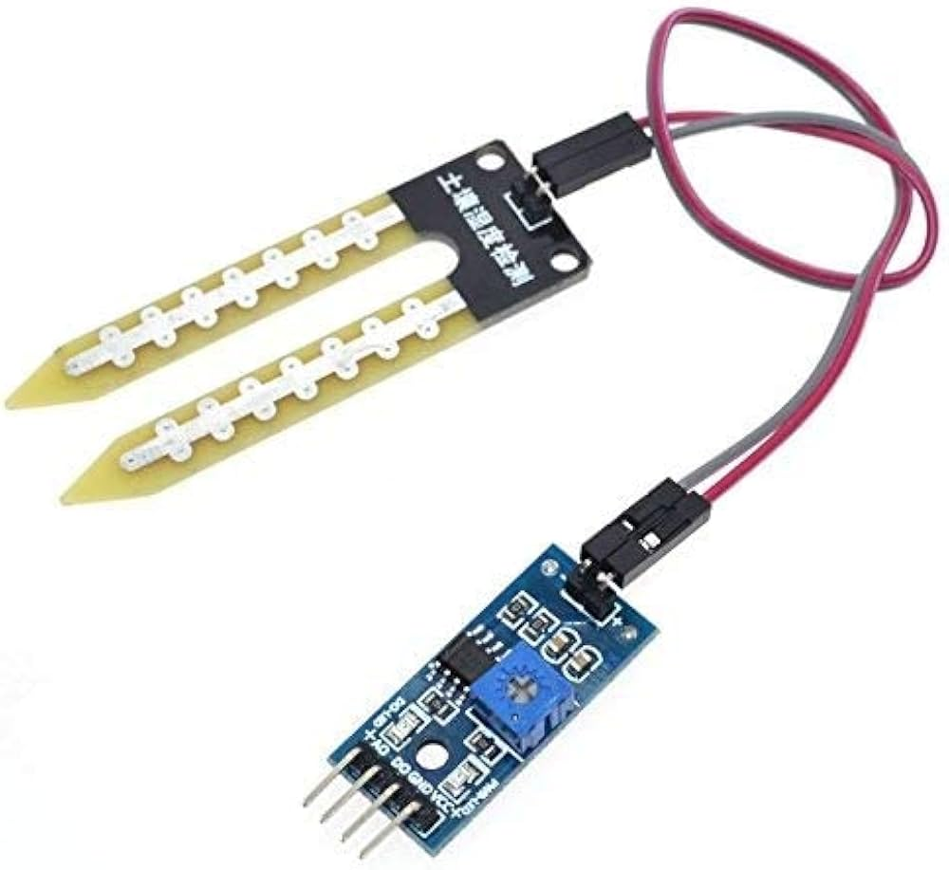

**2)5v relay module**

A 5V relay module is an electronic switching device used to control high-voltage or high-current loads (like water pumps, lights, motors) with a low-voltage control signal from a microcontroller (like Arduino).

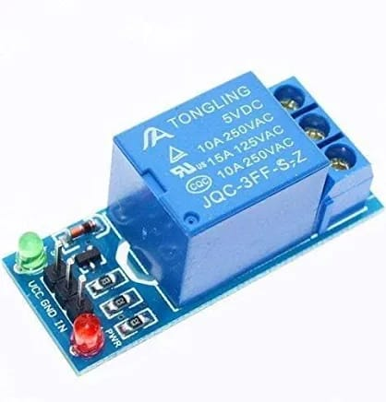

**3)Arduino uno board**

The Arduino Uno is a popular microcontroller development board based on the ATmega328P chip. It serves as the “brain” of the automatic plant watering system by reading sensor inputs, processing data, and controlling outputs like the water pump.

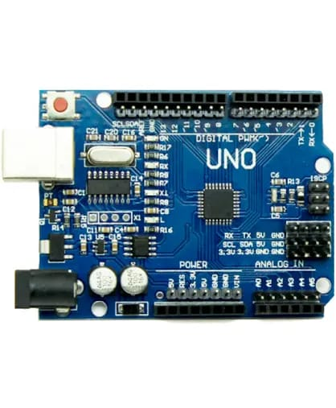

**4)9v Submersible water motor pumps**

A **9V submersible water pump** is a small, electric pump designed to operate underwater and move water efficiently. It is ideal for automatic plant watering systems to deliver water directly to the soil or plant roots.

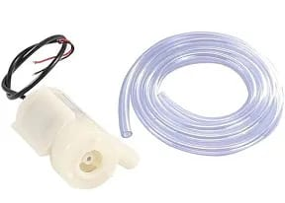

**5) Connecting wires**

**Connecting wires** are essential components used to establish electrical connections between various parts of the automatic plant watering system, such as the sensor, microcontroller, relay module, and water pump.

**Types of Connecting Wires:**

* **Jumper Wires:** Commonly used for breadboard and microcontroller connections. They come with male or female ends and are flexible and easy to use for prototyping.
* **Hook-up Wires:** Insulated single-core or multi-core wires used for permanent or semi-permanent connections.
* **Power Wires:** Usually, thicker gauge wires for carrying higher currents, such as those powering the water pump.

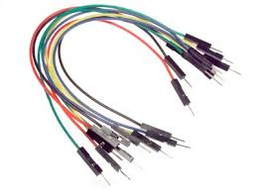

**FINAL PROTOTYPE:**

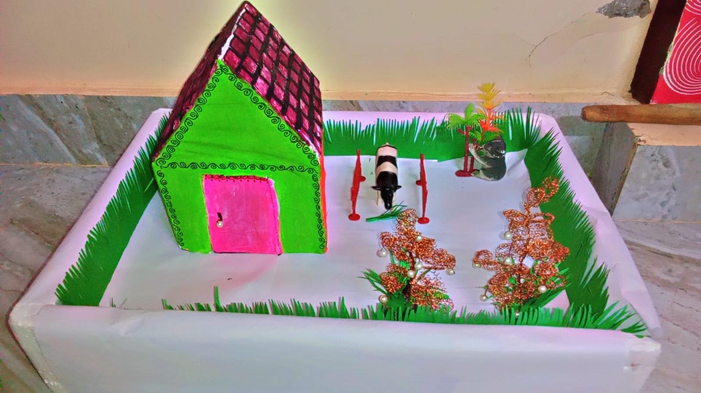

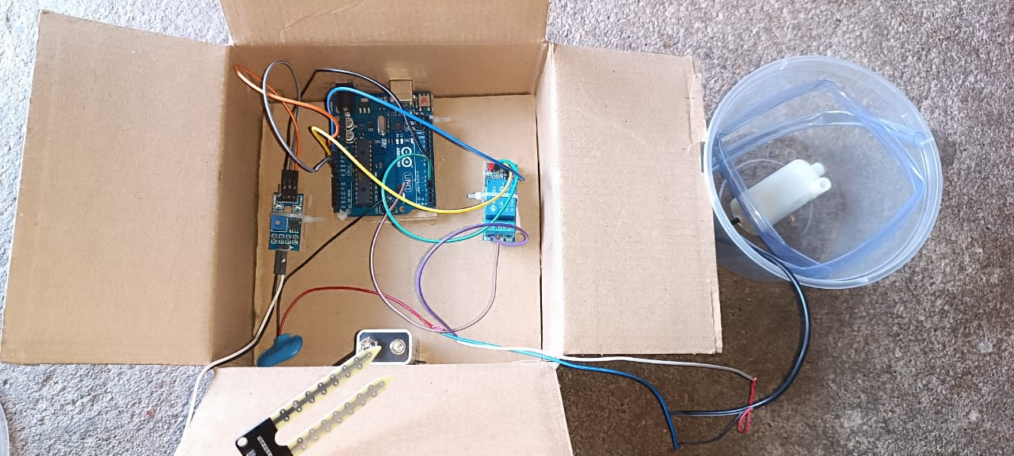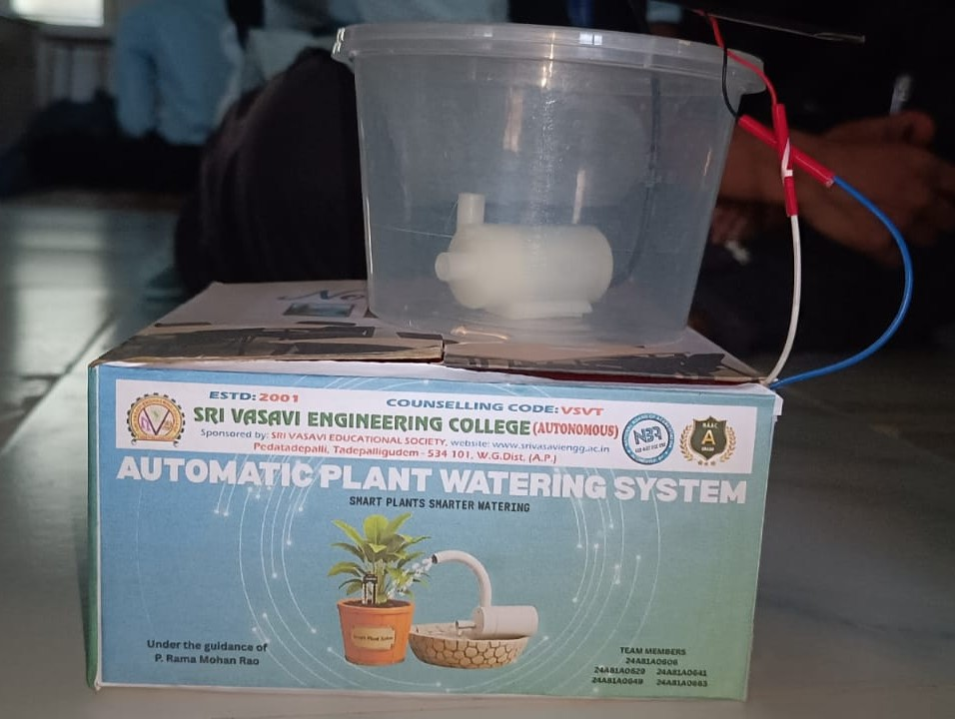

**TESTING**

**AND**

**CONCLUSION**

**Testing**

The automatic plant watering system was thoroughly tested by first verifying the soil moisture sensor’s ability to accurately detect varying moisture levels, which successfully triggered the LM393 comparator’s digital output. The 5V relay module was then tested to ensure it could reliably switch the 9V submersible water pump on and off without delay or malfunction. When integrated, the complete system demonstrated consistent and automatic operation, turning the pump on when the soil was dry and off once the desired moisture was reached, thereby efficiently maintaining optimal soil conditions. Power supply and wiring connections were also checked for stability and safety throughout operation.

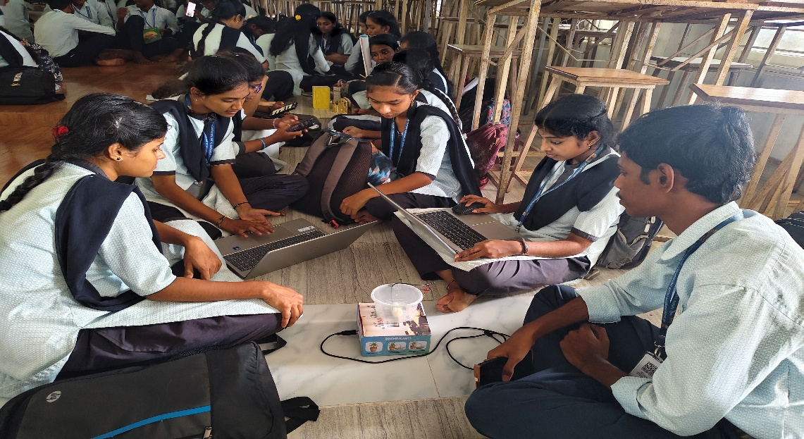

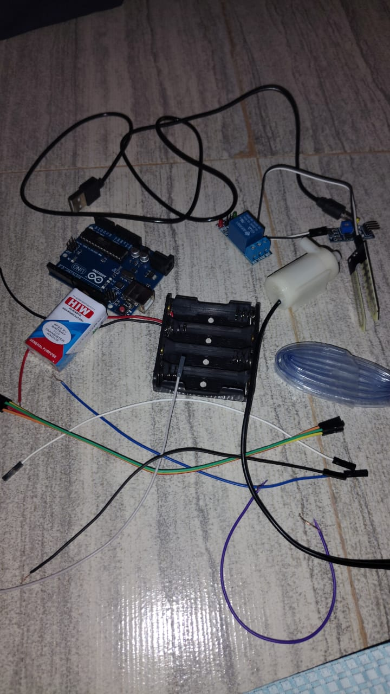

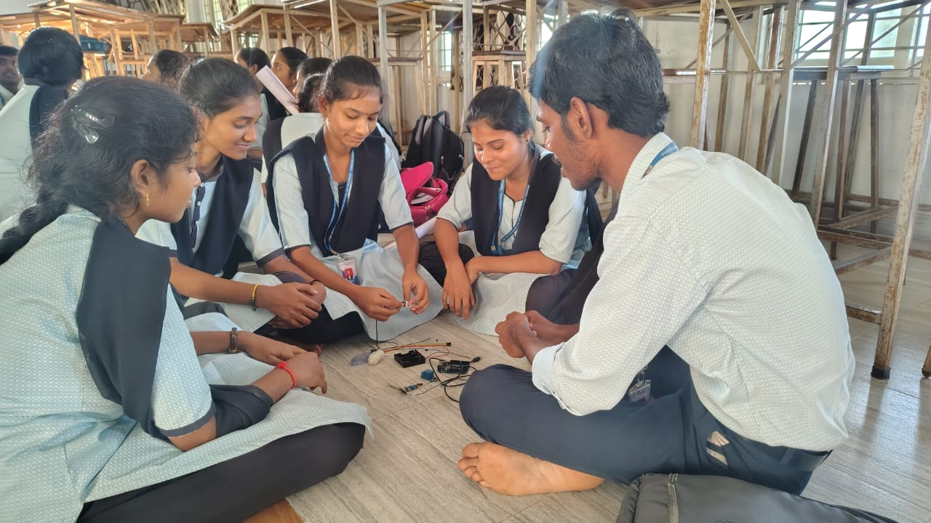

**Testing in Dry State**

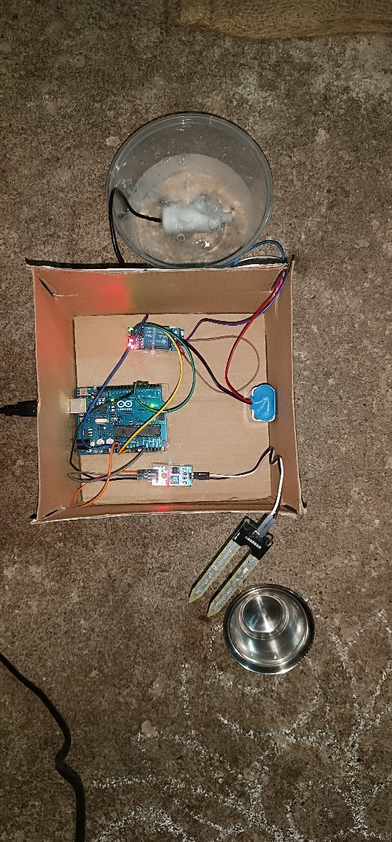

**Testing in Wet State:**

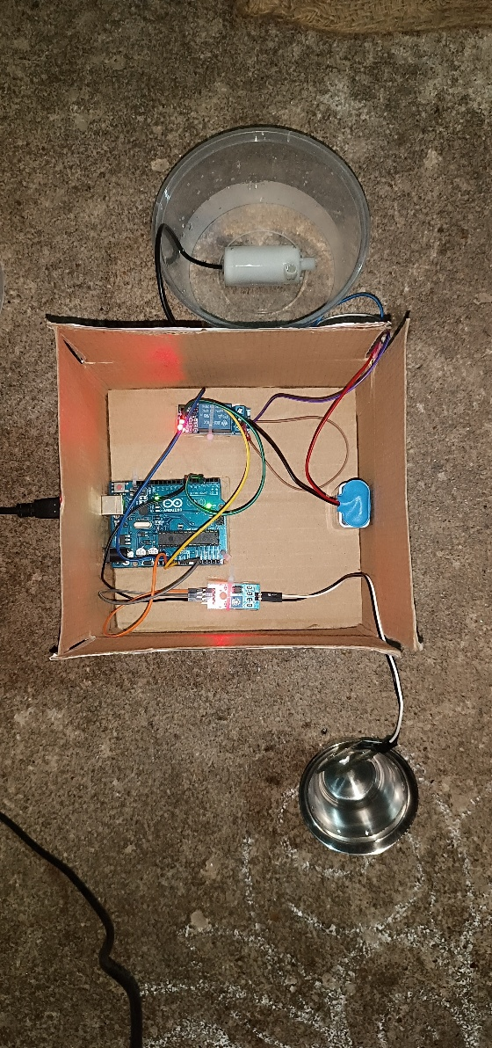

**Conclusion:**

In conclusion, the project effectively automated plant irrigation using sensor feedback and microcontroller control, reducing water wastage and supporting healthy plant growth. This experience enhanced practical skills in electronics, programming, and system design, while highlighting the benefits of automation and sustainable water management in agriculture**.**